Smart File Management & Automation System

1. Objective
This project automates file management tasks like organizing files, renaming files, backup creation, duplicate file removal, empty folder cleaning, and report generation. The system helps users manage files efficiently using Python automation.

2. Technologies Used
- Python
- OS Module
- Shutils
- Logging
- Hashlib
- Datetime

3. Features
- File Organization
- Bulk File Renaming
- Duplicate File Removal
- Backup Creation
- Empty Folder Cleaner
- Report Generation
- Logging System
- Exception Handling

4. Folder Structure
smart-file-management-system/
│
├── main.py
├── requirements.txt
├── README.md
│
├── modules/
│ ├── helper.py
│ ├── organizer.py
│ ├── renamer.py
│ ├── duplicate_remover.py
│ ├── backup_manager.py
│ ├── cleaner.py
│ └── report_generator.py
│
├── logs/
│ └── operations.log
│
├── reports/
│ └── report.txt
│
├── backup/
│
├── test_files/
│
└── screenshots/

5. Code Snippets

Main Menu
print("===== SMART FILE MANAGER =====")
print("1. Organize Files")
print("2. Rename Files")
print("3. Remove Duplicate Files")
print("4. Backup Files")
print("5. Remove Empty Folders")
print("6. Generate Report")
print("7. Exit")

Organizer Function
def organize_files(path):
print("Organizing Files...")

Duplicate Remover
def remove_duplicates(path):
print("Removing Duplicate Files...")

6. Output Screenshots

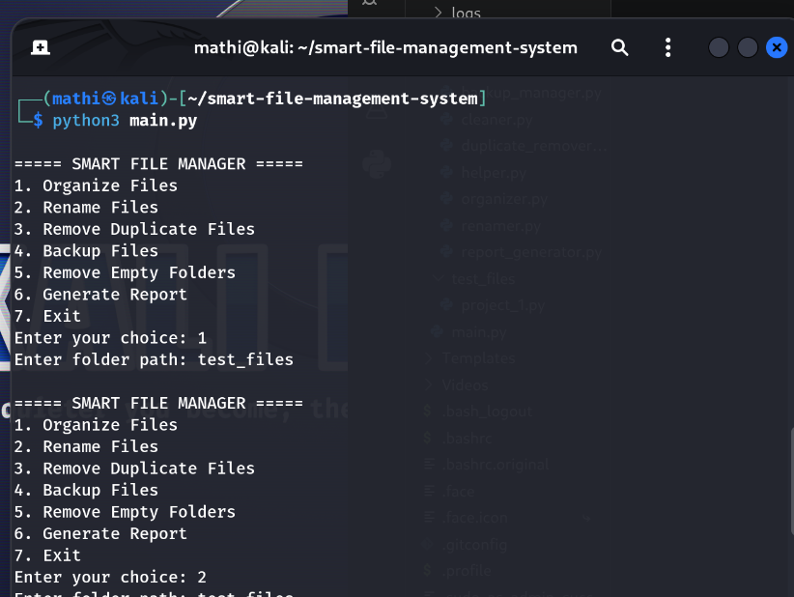

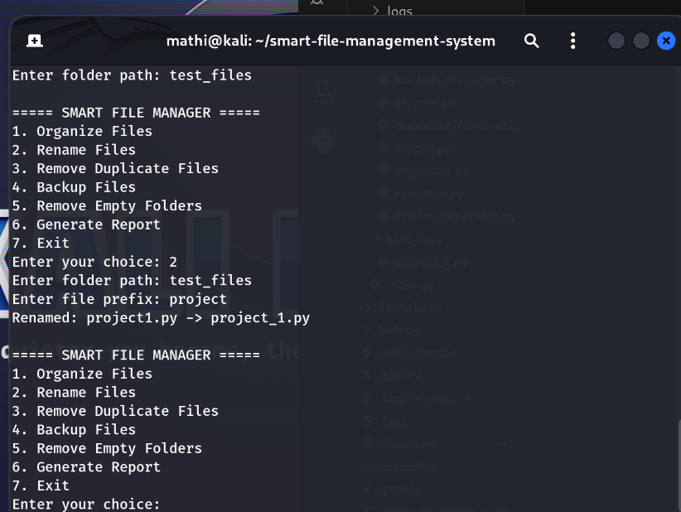

7. GitHub Repository Link
https://github.com/malarmathi23015-lgtm/smart-file-management-automation-system

Conclusion
The Smart File Management & Automation System successfully automates important file handling tasks using Python. This project improved understanding of file handling, modular programming, exception handling, logging systems, and automation concepts.

Author
Mathivadhana V

